|  |  |
| --- | --- |
| LILLEBAKK cmyk |  |

Datasheet

Project NAME:

Customer: KJELLER VINDTEKNIKK

Features

* Loadcell logger with 1s to 3600s selectable sampling rate.
* The logger will measure and store the average, minimum and maximum tension from the loadcell.
* The resolution of the logger is 11 bits, i.e. approx. 7kg for a 0 - 15tonn range.
* The logger will average the samples and transmit the values at a rate from 60s to 3600s.
* The logger will store up to 10 days of measurements at the fastest transmission rate.
* Lost transmissions will be re-sent at the next available occasion.
* The battery lifetime is 10 years at 5s sampling rate and 600s transfer rate.

Contents

[Datasheet 1](#_Toc491253878)

[Project NAME: LE\_NB\_IOT\_CONTROLLER 1](#_Toc491253879)

[Customer: KJELLER VINDTEKNIKK 1](#_Toc491253880)

[1. Module Interface 2](#_Toc491253881)

[2. Electrical Characteristics 3](#_Toc491253882)

[2.1.1. Measurement resolution in current system 4](#_Toc491253883)

[2.1.2. Measurement resolution in the new system 4](#_Toc491253884)

[3. Radio controller 5](#_Toc491253885)

[3.1. Main target; BC95 LTE Cat NB1, 3GPP, Narrow Band IoT (Quectel) 5](#_Toc491253886)

[3.2. Alternative targets 5](#_Toc491253887)

[3.2.1. BG96, LTE Cat M1, eMTC 5](#_Toc491253888)

[3.2.2. M95 5](#_Toc491253889)

[4. Data format and storage capacity 7](#_Toc491253890)

[5. Cost 8](#_Toc491253891)

[6. Deliverables 9](#_Toc491253892)

[7. Module Background 10](#_Toc491253893)

[7.1. Initial coverage 10](#_Toc491253894)

[8. Control Modes 14](#_Toc491253895)

[9. Operation system description 15](#_Toc491253896)

[9.1. Block diagram 15](#_Toc491253897)

[9.2. Operation system overview 15](#_Toc491253898)

[9.3. Error messages 15](#_Toc491253899)

[10. Current load cell system 16](#_Toc491253900)

[10.1. Top level system 16](#_Toc491253901)

[10.2. Sensor module 17](#_Toc491253902)

[10.3. Measurement and communication module 18](#_Toc491253903)

[10.4. Sensor – Measurement module link 20](#_Toc491253904)

[10.5. Iokeys SW 22](#_Toc491253905)

[11. Test Plan 23](#_Toc491253906)

[11.1. Test Modes for this Module 23](#_Toc491253907)

[11.2. Prototype Verification and Characterization 23](#_Toc491253908)

[11.3. Measurement bench setup 23](#_Toc491253909)

[11.3.1. Load cell measurements 23](#_Toc491253910)

[11.3.2. Xplained Xmega 1AU + click M95 measurements 23](#_Toc491253911)

# Module Interface

Table 1: Pin description

|  |  |  |  |  |
| --- | --- | --- | --- | --- |
| **Pin name** | **Type** | **Domain (V)** | **Description** | **Comments** |
| Cabled sensors |  |  |  |  |
| USB/COM |  |  |  |  |
|  |  |  |  |  |
|  |  |  |  |  |
|  |  |  |  |  |
|  |  |  |  |  |
|  |  |  |  |  |
|  |  |  |  |  |
|  |  |  |  |  |
|  |  |  |  |  |

# Electrical Characteristics

Verification levels:

1. Specification concept 2 (final product)
   1. Specification concept 1 (pilot)
2. Measurements concept 0 (bench setup)
3. Measurements concept 1 (pilot in field)
4. Measurements concept 2 (final product in field)

Table 2: Electrical characteristics

|  |  |  |  |  |  |  |  |  |
| --- | --- | --- | --- | --- | --- | --- | --- | --- |
| **Parameter** | **Test #** | **Parameter name** | **Condition** | **Ver. level** | **Min** | **Typical** | **Max** | **Unit** |
| **Operating Conditions** | | | | | | | | |
| Ambient temperature |  | temp |  | I | -20 | 25 | 50 | °C |
| Battery voltage |  | Vbat |  | I | 2,0 | 3,6 | 3,7 | V |
| Battery capacity |  |  | 10 years life time | I | 5 |  | 17 | Ah |
| Ground |  | Gnd |  | I |  | 0 |  | V |
| Supply voltage Load cell[[1]](#footnote-1) |  | Vlc |  | I |  | 3,4 |  | V |
| Supply voltage IA[[2]](#footnote-2) |  | Via |  | I | 4 |  | 16 | V |
| Supply voltage OPAMP |  | Vopa |  | I | 2,3 |  | 5,5 | V |
| Supply voltage RF |  | Vrf |  | I | 3,1 | 3,8 | 4,2 | V |
| Supply voltage MCU |  | Vmcu |  | I | 1,6 |  | 3,6 | V |
| Supply voltage ext MEM |  | Vmem |  | I | 1,8 |  | 5,5 | V |
| Supply voltage REG |  | Vreg |  | I | 1,8 |  | 5,5 | V |
| Sampled data size |  | Ms |  | I |  | 16 |  | B |
| Internal data storage |  | Mint | Program memory | I |  | 16 |  | kB |
| External storage |  | Mext | Non-volatile EEPROM | I |  | 256 |  | kB |
| Sampling rate | 1 | Ts |  | I | 1 | 5[[3]](#footnote-3) | 3600 | s |
| Data transmission rate | 2 | ttx |  | I | 60 | 600 | 3600 | s |
| Averaging time |  | Tavg | Currently the same and in sync with ttx | I | 60 | 600 | 3600 | s |
| **DC Characteristics** | | | | | | | | |
| Average supply current |  | Iavg | NB-IoT | I |  | 60 |  | uA |
| GPRS | I |  | 1360 |  |
| II |  | 1340[[4]](#footnote-4) |  |  |
| Regulator output voltage |  |  |  | I | 3,3 | 3,7 | 4,0 | V |
| Battery lifetime | 3 | Tbat | NB-IoT | I | 2 | 10 |  | years |
| Ia |  | 1[[5]](#footnote-5) |  |
| GPRS | I |  | 0,4 |  |
| II |  | 0,4 |  |
| Ia |  | 1[[6]](#footnote-6) |  |
| Internal storage span |  |  | 16B/second | I |  | 900 |  | s |
| External storage span | 4 |  | 16B/60 seconds | I |  | 10 |  | days |
| Total weight |  |  |  |  |  | ? |  |  |
| **Transient Characteristics** | | | | | | | | |
| Peak supply current |  |  | Including Tx burst. | I |  | 2 |  | A |
|  |  |  |  |  |  |  |  |  |
|  |  |  |  |  |  |  |  |  |
| Supply IR drop |  |  | Including Tx burst. | I |  |  | 200 | mV |
| Transmission time |  |  |  | I |  | 10 |  | ms |
| Wake-up time from sleep |  |  |  | I |  | 100 |  | ms |
| Start-up time from power down |  |  |  | I |  | 30 |  | s |
| Transmission burst time |  |  |  | I |  | 1 |  | ms |
|  |  |  |  |  |  |  |  |  |
| **AC Characteristics** | | | | | | | | |
| Transfer error rate | 5 | TER |  | I |  |  | 5 | % |
| Ia |  |  | 20 |
| PSRR |  |  | During sampling | I | 40[[7]](#footnote-7) |  |  | dB |
| **Sensor Characteristics** | | | | | | | | |
| Tension range | 6 | Ffsr |  | I | 0 |  | 150 | kN |
| Total tension error | 7 | Ferr |  | I | -500 |  | +500 | N |
|  | Ia | -900 |  | +900 |
| Tension resolution | 8 | Flsb |  | I |  | 73 |  | N |
|  | Ia |  | 300 |  |
| Load cell output voltage |  | Vfout |  | I | 1,000 |  | 2,000 | V |
| Tension transients |  | Ftran | Galloping | II |  | Tbd |  | N |
|  |  |  |  |  |  |  |  |  |

### Measurement resolution in current system

The information given by the current system states:

* Supply = 3,4V into the load cell
* Measurement range = [1,000, 2,000]V.
* Measurement resolution = 0,5mV.
* Total error of +-500N (100kN version).
* Assuming the total non-linearity is 0,5mV. It’s not stated whether this is the total peak to peak, or any direction. In the best case scenario it is total peak to peak giving +-0,25mV/1V. The resolution of the system would be ~12 bits, hence ~11bits if it is +-0,5mV.
* In the web page it’s stated a resolution of 1/2222 => ~11 bits (100kN version).
* The microcontroller’s ADC is 10 bits only (or even 8), single ended. And the range is from 1-2V, hence it must have 11 bits resolution in that limited area.

### Measurement resolution in the new system

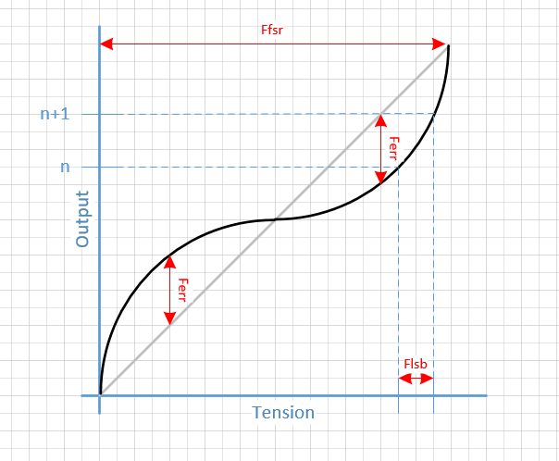

# Radio controller

## Main target; BC95 LTE Cat NB1, 3GPP, Narrow Band IoT (Quectel)

Have it currently on a dev kit.

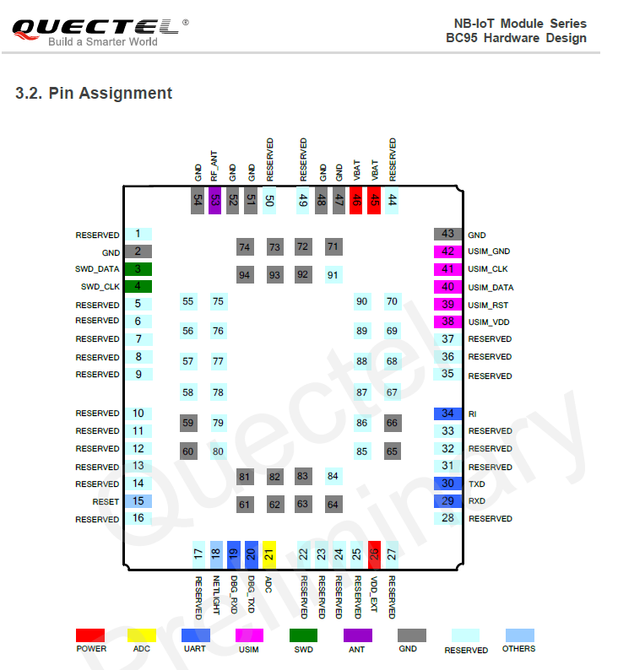

## Alternative targets

### BG96, LTE Cat M1, eMTC

Com4:

Finnes en BG96, støtter både LTE Cat M1 og fallback til GPRS/Edge, se vedlagt.

Spurte PM om vi kan få et par stk nå.

Den er pin-kompatibel med BG95, så dette bør være en ideel modul inntil man får NB opp å kjøre. Cat M1 har man ikke bestemt seg for i Norge, men i US og andre markeder enabler man dette nå.

Quectel:

* BG96: LTE Cat M1, Cat NB1 and EGPRS.
* Pin compatible with BC95, UG95/UG96 and M95.

### M95

Low end GPRS.

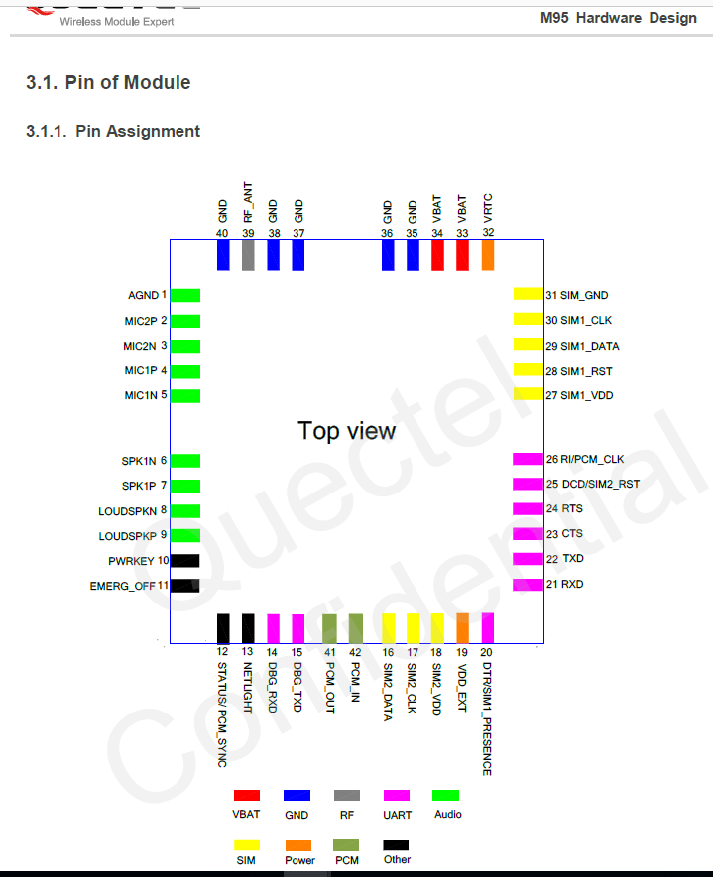

# Data format and storage capacity

See: <le_nb_iot_controller_current_consumption.xlsx>.

# Cost

See: [budsjett presentasjon concept0.xlsx](budsjett%20presentasjon%20concept0.xlsx).

# Deliverables

TBD.

# Module Background

This module is based upon the LPWAN SRD: [..\LE\_LPWAN\_SYSTEM\doc\lpwan\_system\_requirement.docx](file:///C:\Users\jan.rune.herheim\Dropbox%20(Lillebakk)\Lillebakk%20Team\herheim\Documents\GitHub\LE_NB_IOT_CONTROLLER\LE_LPWAN_SYSTEM\doc\lpwan_system_requirement.docx)

## Initial coverage

Wish from KJELLER VINDTEKNIKK:

Lastcelle i høyspentmast :

|  |  |
| --- | --- |
| **NORD** | 60.1889461  60° 11.3367684'  60° 11' 20.2061'' |
| **ØST** | 6.2401207  6° 14.4072426'  6° 14' 24.43455'' |

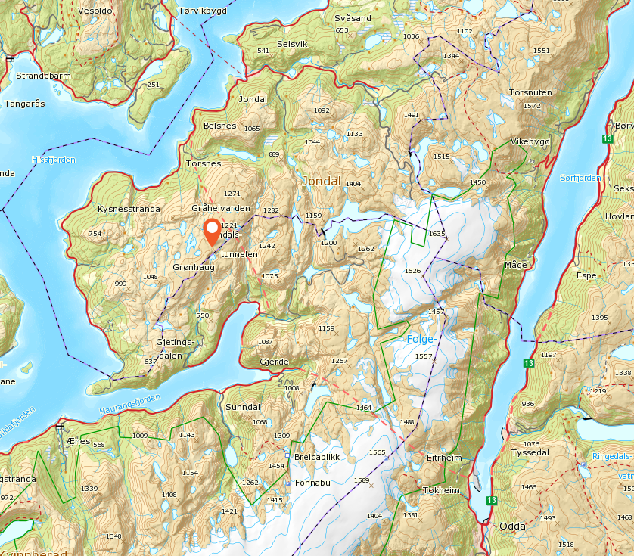

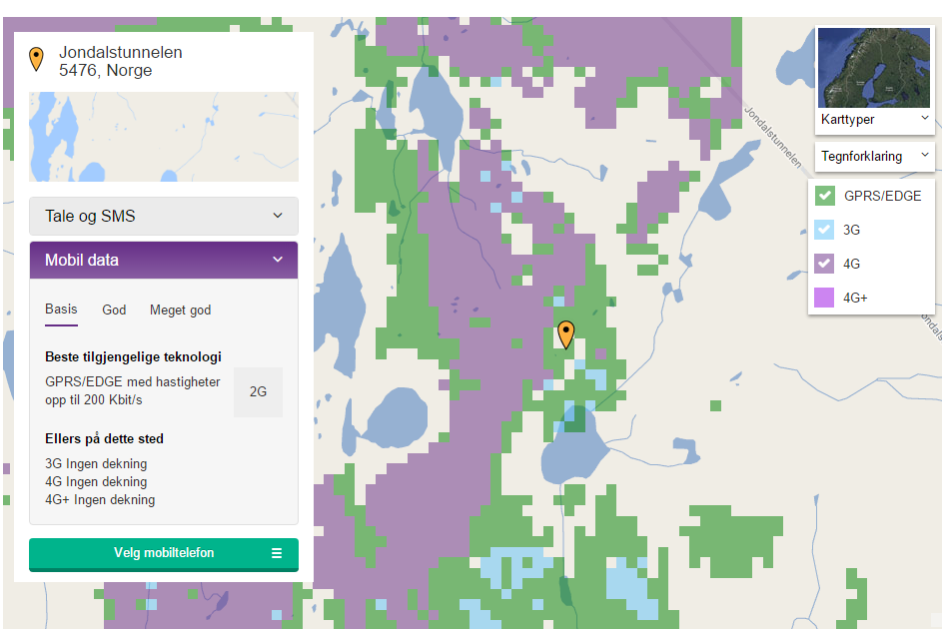

Mulig prøvespenn:

|  |  |
| --- | --- |
| **NORD** | 60.1616694  60° 9.7001652'  60° 9' 42.00991'' |
| **ØST** | 6.1779481  6° 10.6768846'  6° 10' 40.61308'' |

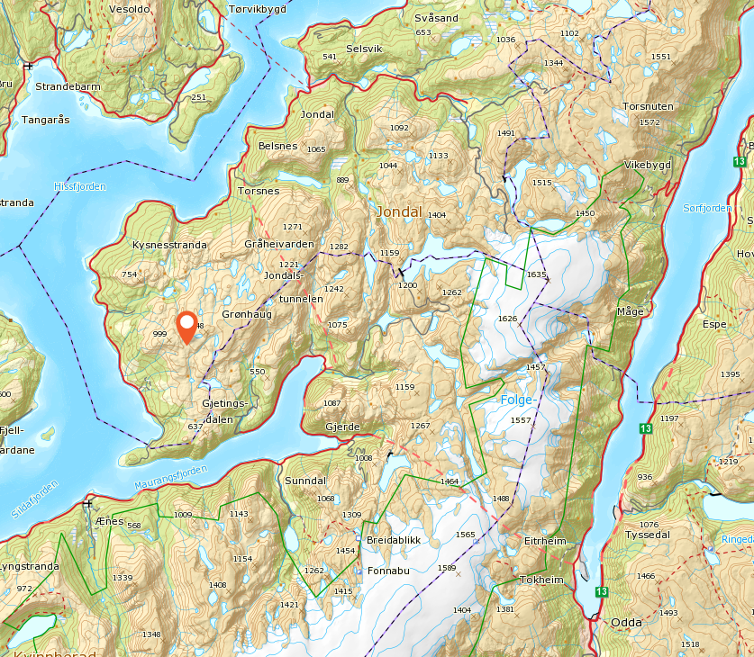

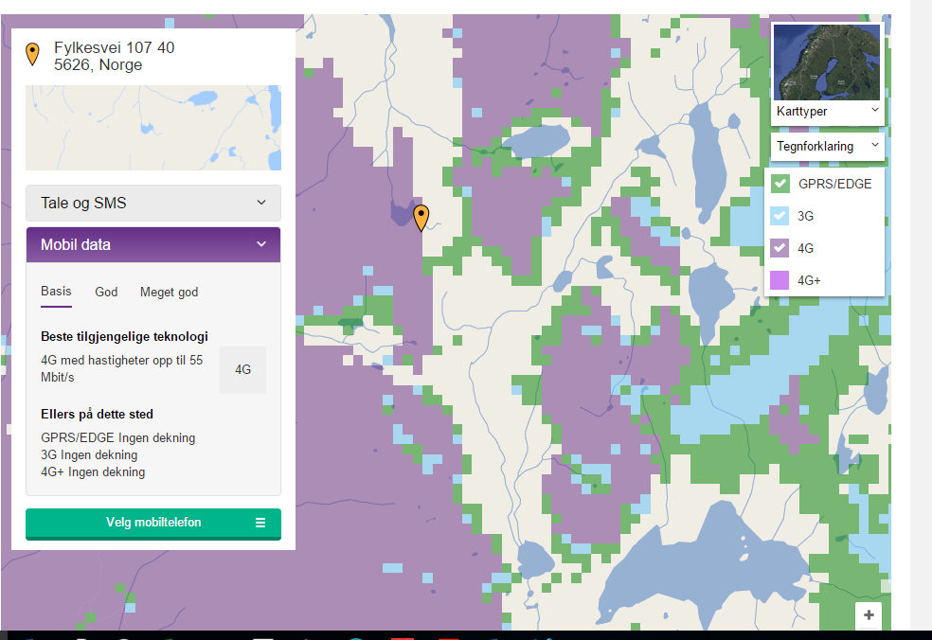

# Control Modes

Table 3: States

|  |  |  |  |  |  |  |
| --- | --- | --- | --- | --- | --- | --- |
| **Inputs** | | | **Outputs** | | |  |
|  |  |  |  |  |  | **Comments** |
|  |  |  |  |  |  |  |
|  |  |  |  |  |  |  |
|  |  |  |  |  |  |  |
|  |  |  |  |  |  |  |
|  |  |  |  |  |  |  |

Table 4: Calibration

|  |  |  |  |
| --- | --- | --- | --- |
| **Signals** | **Descriptions** | **Settings** | **Results** |
|  |  |  |  |
|  |  |  |  |
|  |  |  |  |
|  |  |  |  |
|  |  |  |  |

# Operation system description

AT commands are listed in: quectel\_docs\Quectel\_BC95\_AT\_Commands\_Manual\_V1.0.pdf

## Block diagram



## Operation system overview

See: <le_nb_iot_controller_blockdiagram.vsdx>.

## Error messages

Tbd.

# Current load cell system

Supplied info about the current measurement system:

[doc\iokeys\iokeys\_RTL\_End\_Cap\_and\_O-ring\_info\_01.pdf](doc/iokeys/iokeys_RTL_End_Cap_and_O-ring_info_01.pdf)

[doc\iokeys\iokeys\_GST\_Software\_info\_01.pdf](doc/iokeys/iokeys_GST_Software_info_01.pdf)

<http://www.iokeys.com/load1.htm>

## Top level system

* 2,4GHz communication between sensors and base station.

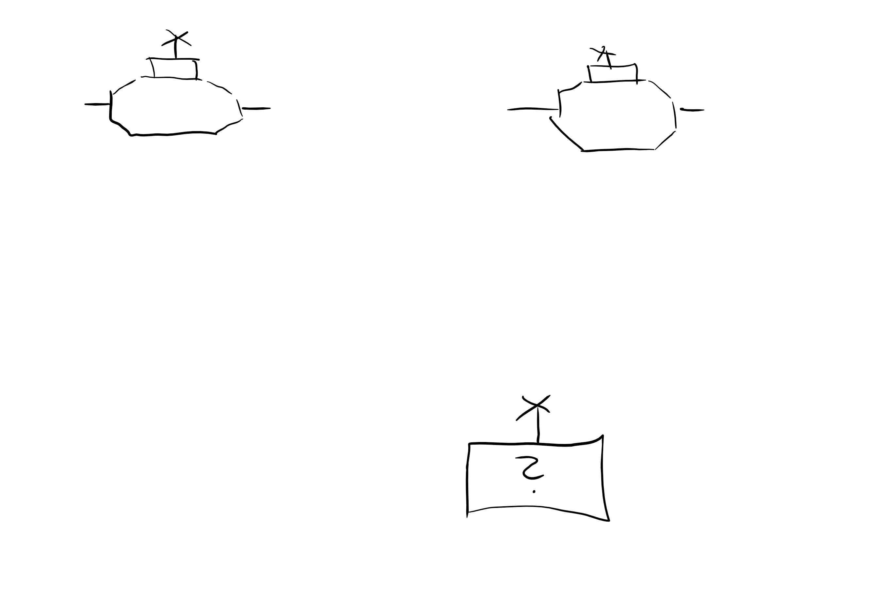

* Current load cell system consists of:
  + A load cell with an integrated sensor module (IA).
  + An add-on measurement and radio communication module.

Ideally only the measurement and radio communication module should be replaced.

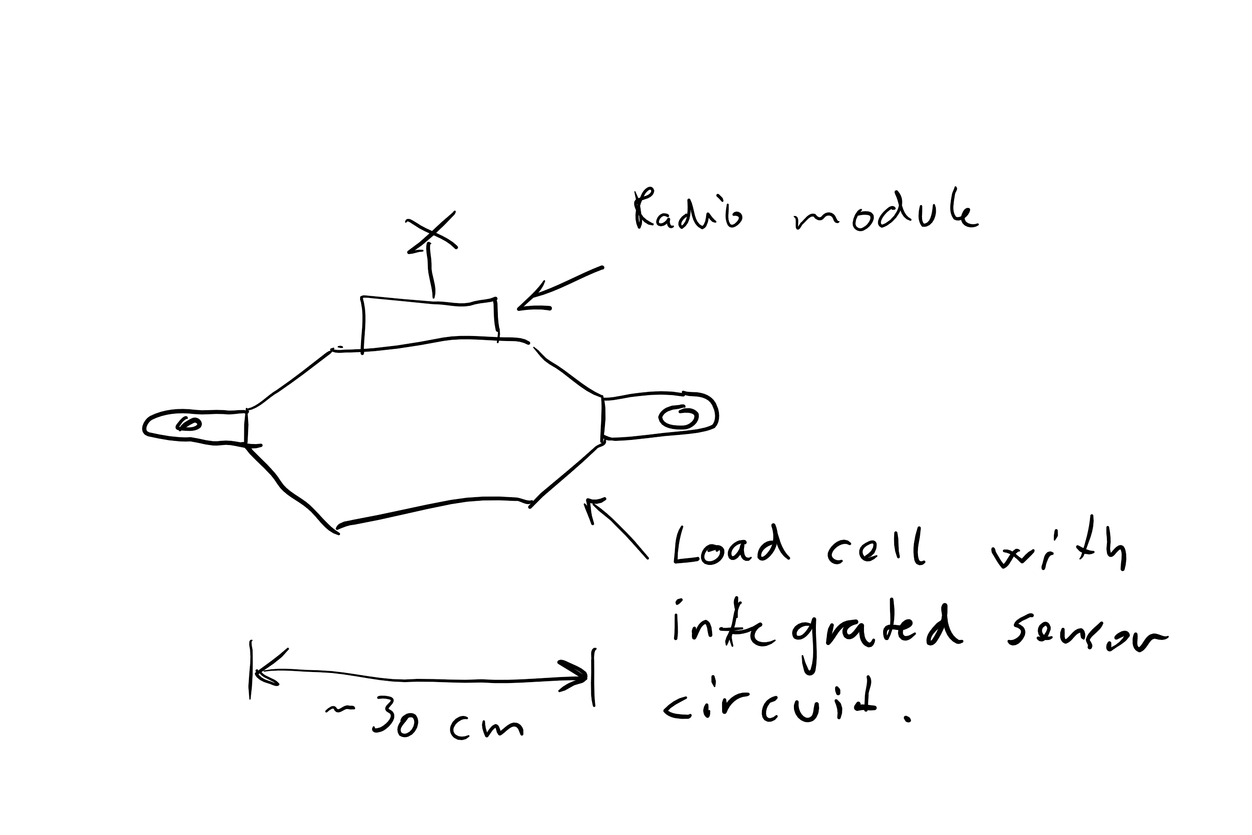

## Sensor module

Tension range

Vout = [1,000, 2,000]V

Resolution: 0,5mV.

* ~11 bits

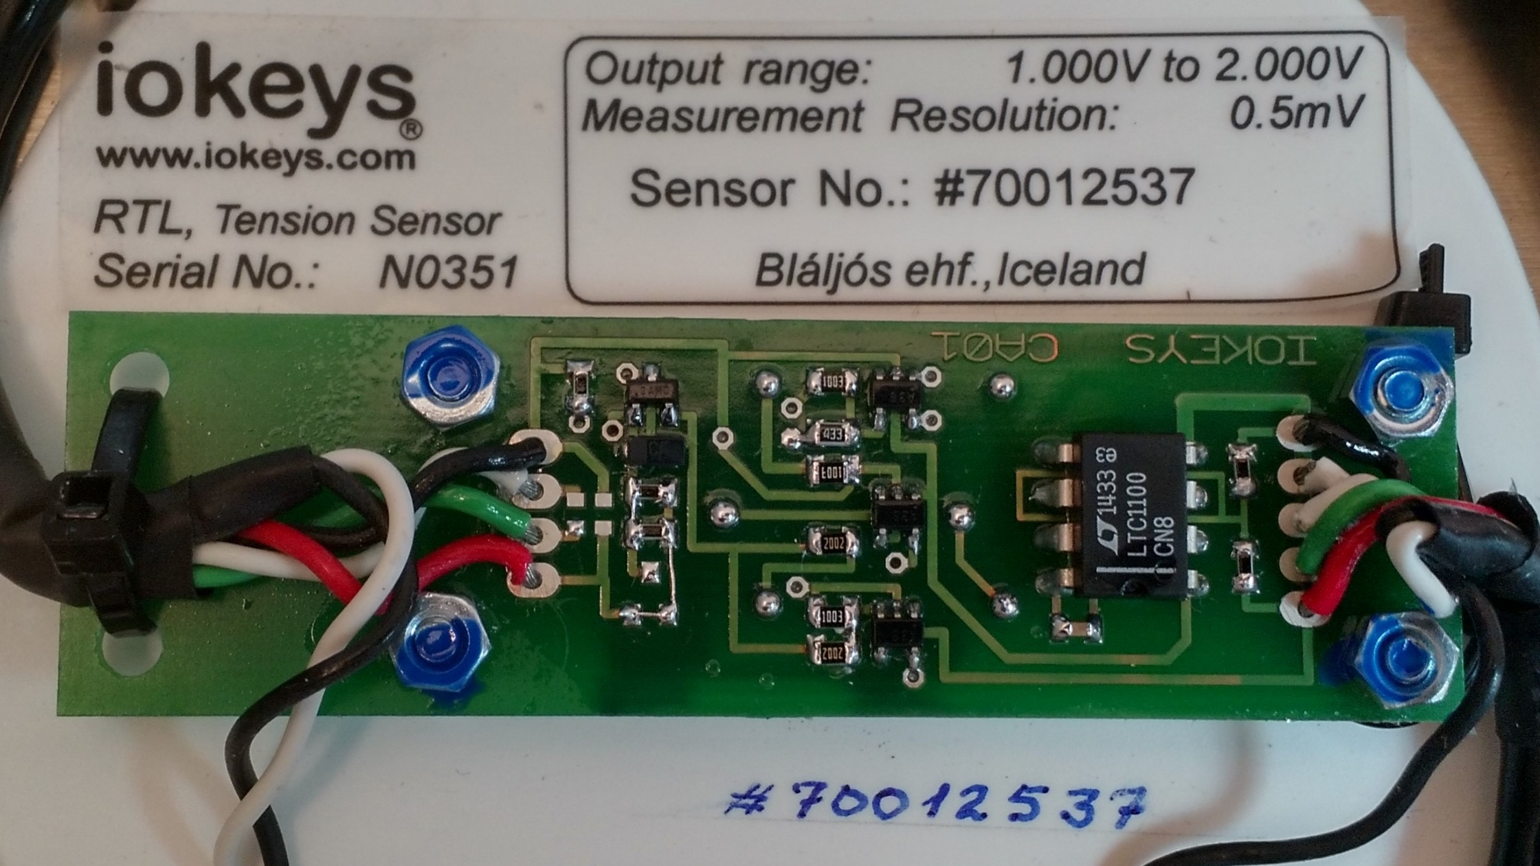

The base is a LTC1100 CN8 IA from Linear.

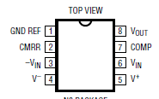

OPA336 is marked A36, seems to be three of these on the board.

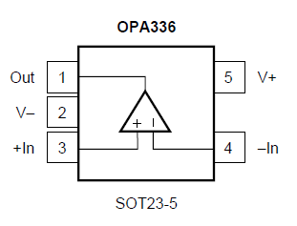

## Measurement and communication module

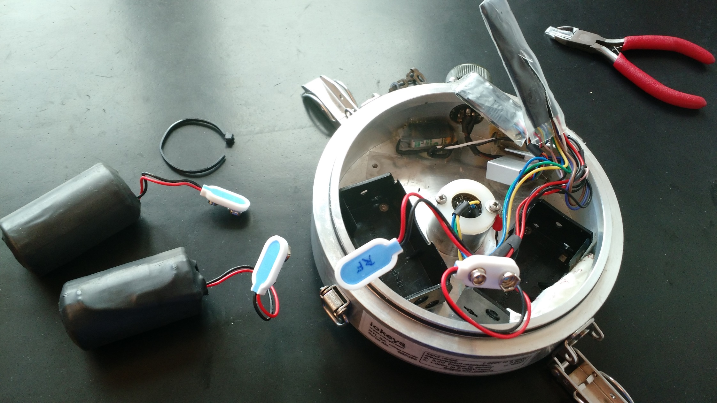

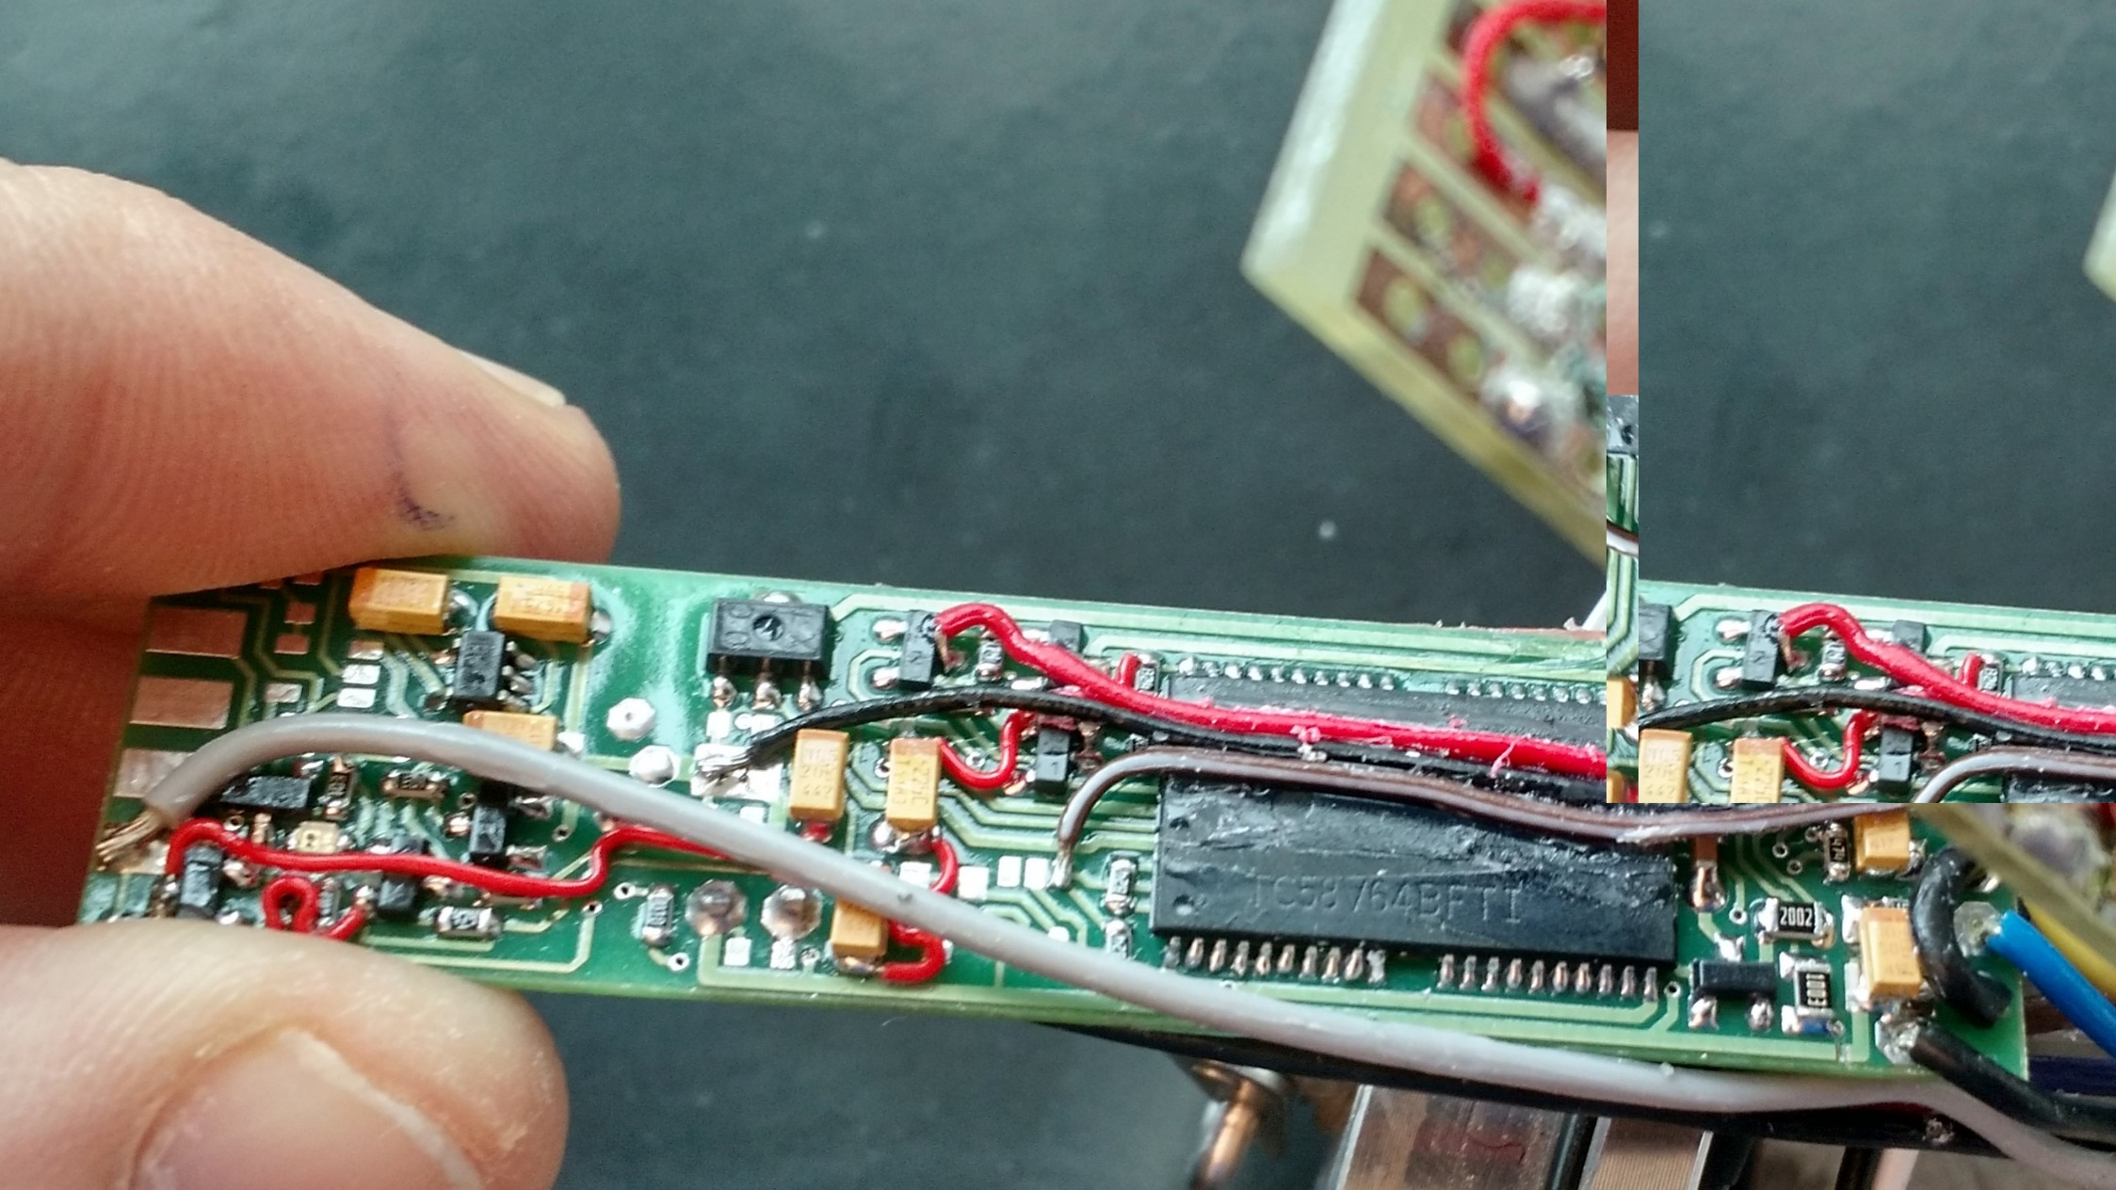

The large IC seems to be a memory circuit (eeprom) from Toshiba. The below snip is from an AF version, while the above is BFTI. I don’t know the difference yet.

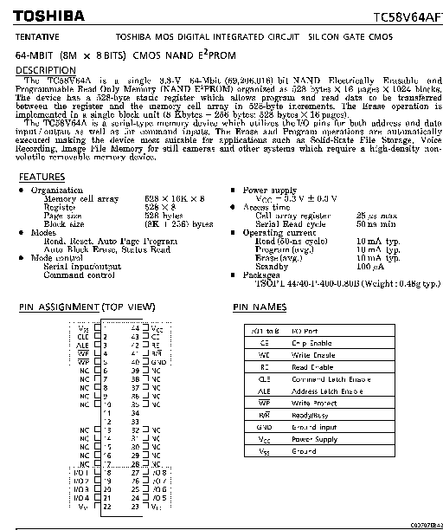

Seems to be a NEC MCU,

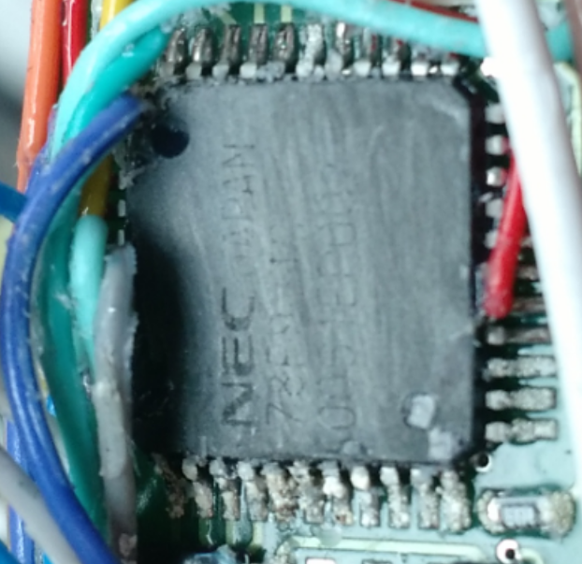

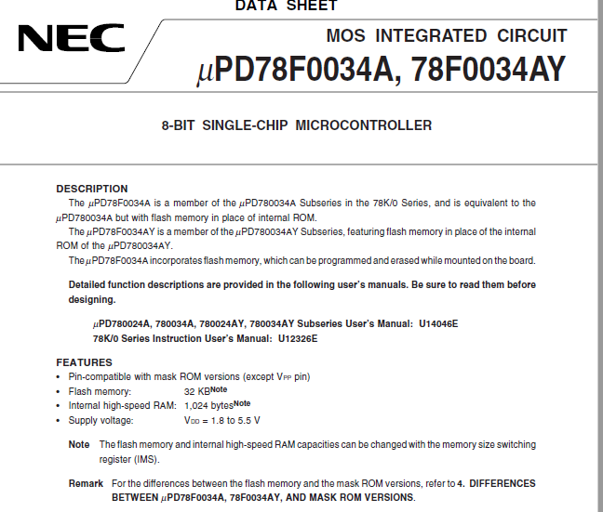

Could this be the wifi module?

## Sensor – Measurement module link

6 pin connector sensor:

1. Nc
2. Nc
3. Gnd (black)
4. Vdd (red)
5. (white left = white top right)
   1. White bottom right = Vin is connected with 0,3k to white left.
6. Vout\_buf (green left)
   1. Green right = -Vin is connect with 100k to green left.

* All pins on the left side is sent to the communication module.



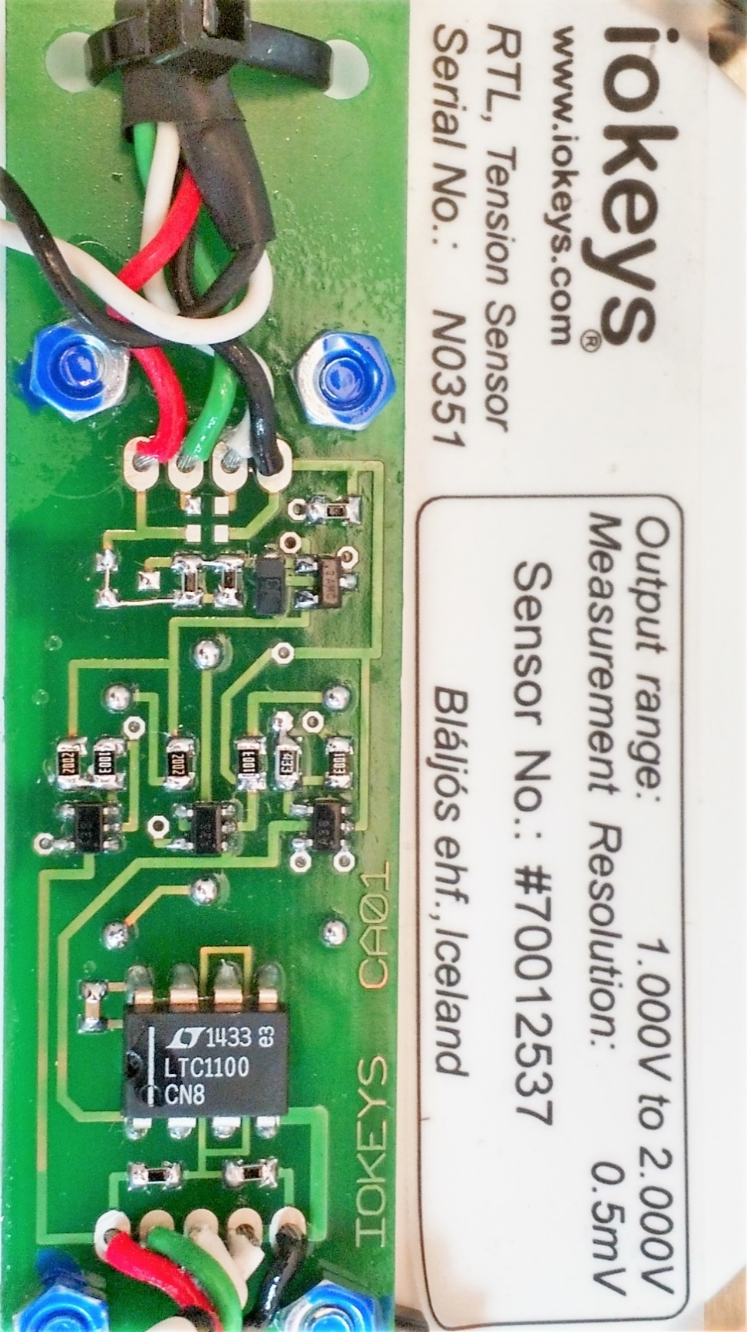

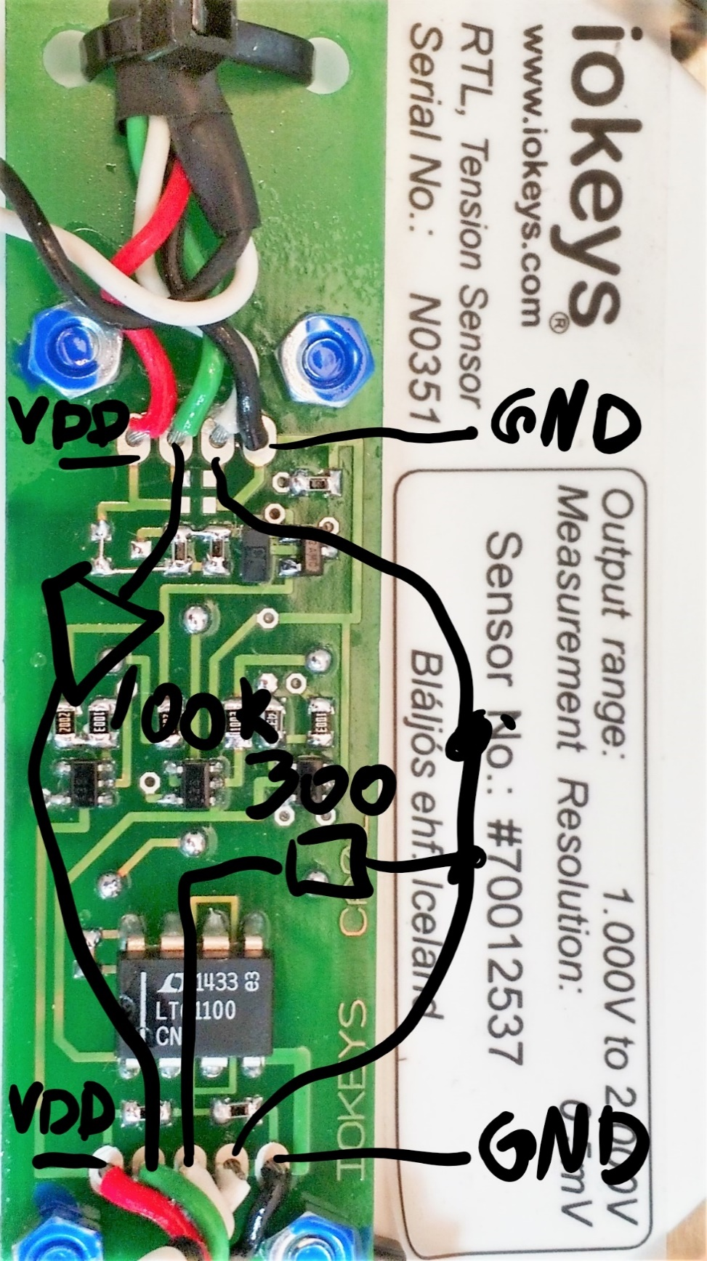

6 pins connector measurement module:

1. Nc
2. Nc
3. Gnd (black)
4. Vdd (green)
5. (blue)
6. (yellow)

Based upon the below marking on the load cell it seems like the input supply voltage is 3,4V. The blue pin from the connector is unknown, but the yellow seems to be the buffered output sent to the ADC/MCU.

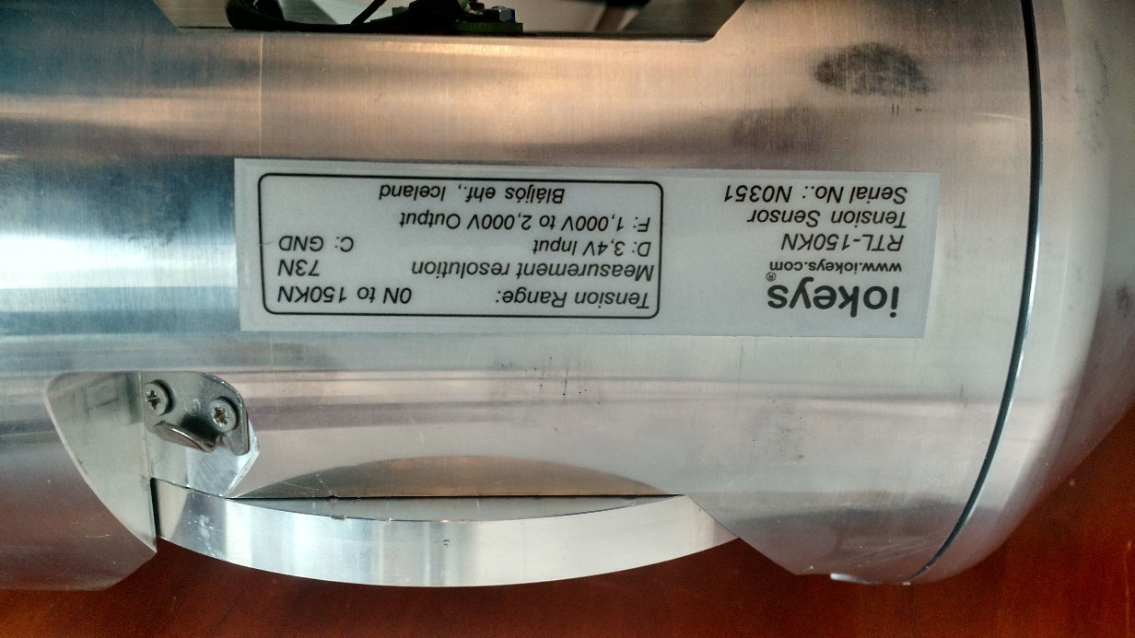

6 pins connector measurement module debug port:

1. (brown)
2. (purple)
3. Gnd (black)
4. Nc
5. Nc
6. Nc

The below snip is for the ground station controller, but is probably the same for the communication module debug port (RS-232).

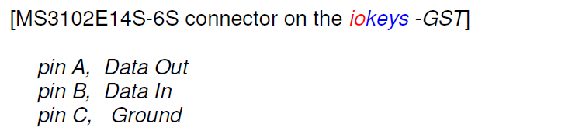

## Iokeys SW

The iokeys SW is functional towards both communication modules we have available. The module enabled in January has some data stored.

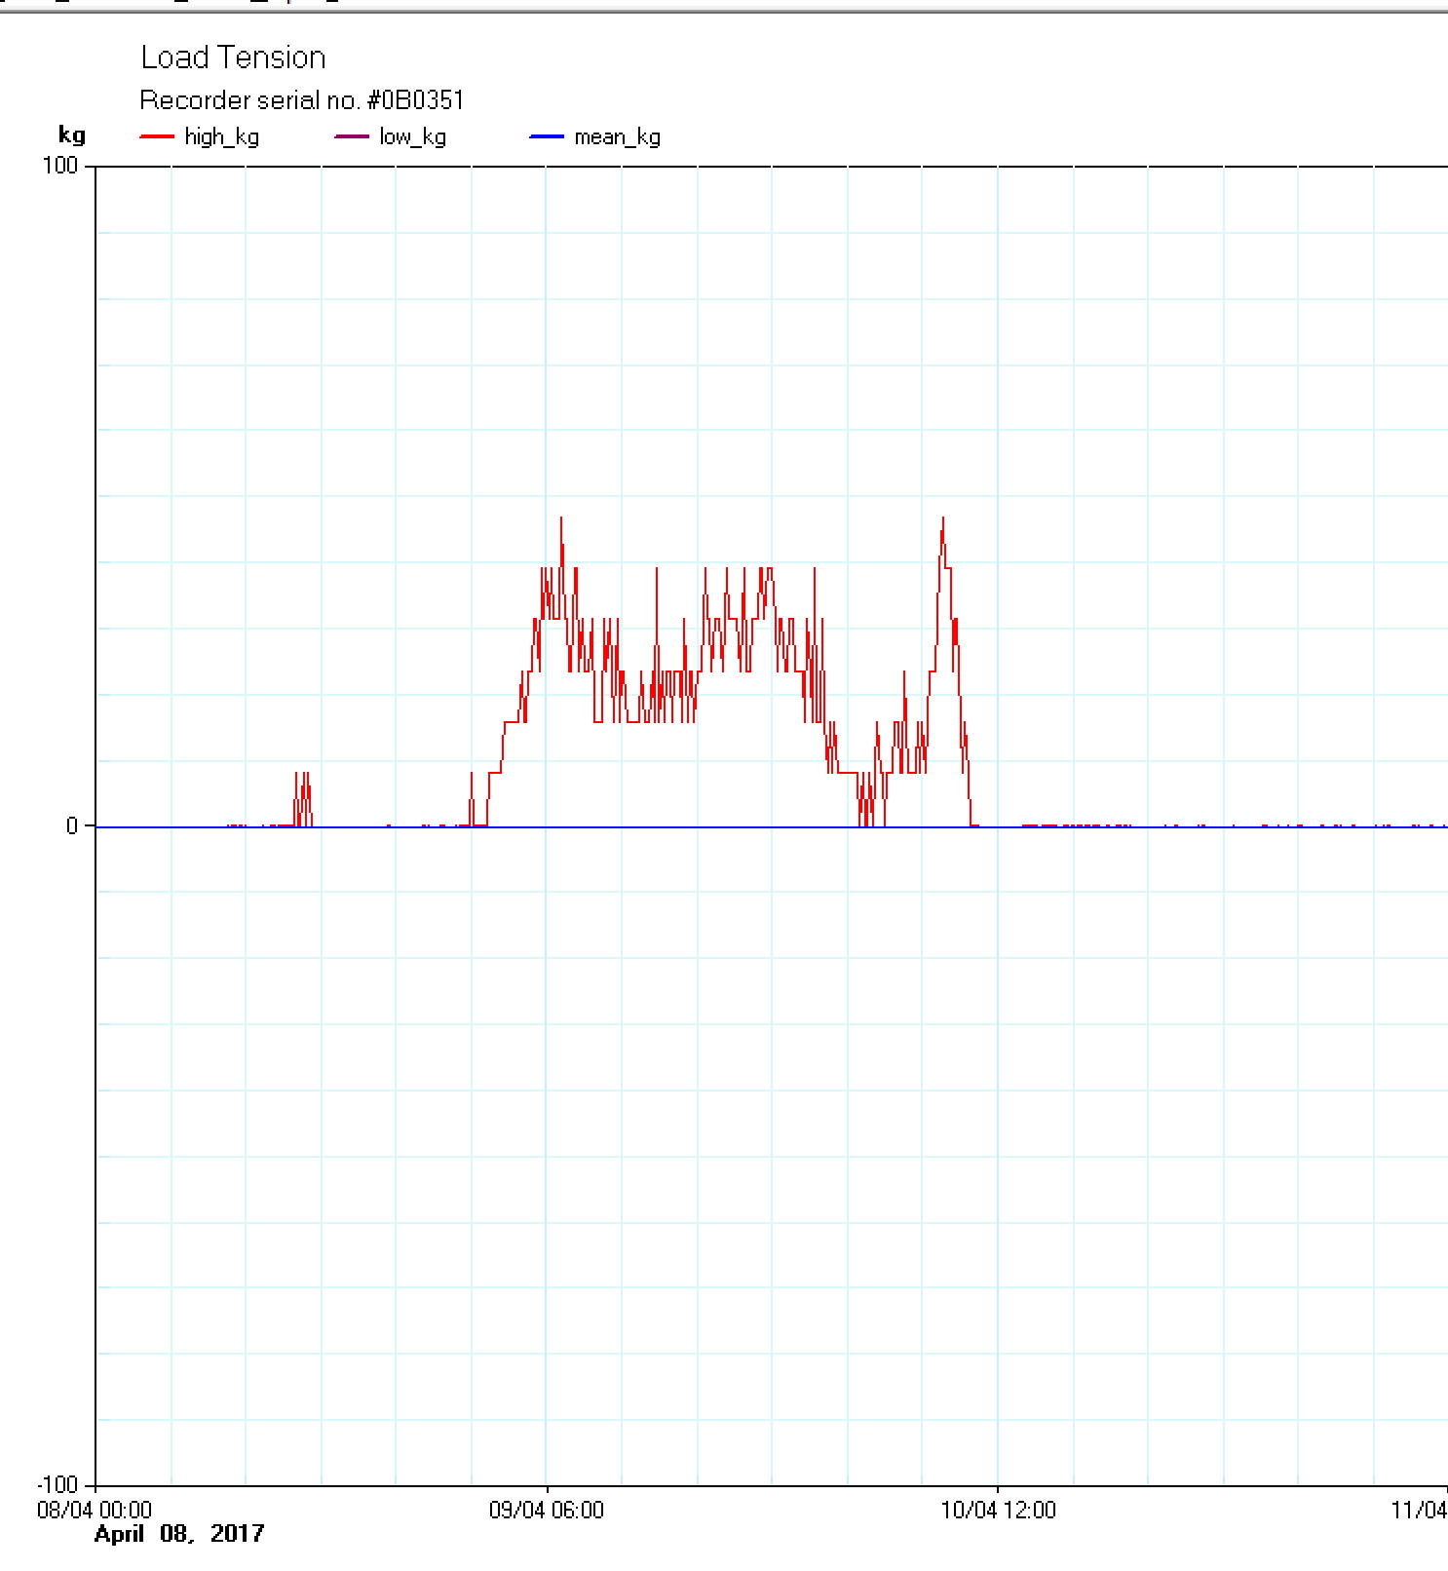

# Test Plan

Table 5: Test conditions

|  |  |  |  |  |
| --- | --- | --- | --- | --- |
| **Temperature** |  |  |  |  |
|  |  |  |  |
| **Supply** |  |  |  |  |
|  |  |  |  |
| **Load** |  |  |  |  |
|  |  |  |  |

## Test Modes for this Module

<Explain clearly what kind of test modes are implemented in the module>

## Prototype Verification and Characterization

<Explain clearly how the prototype should be verified and characterized. List and sequence the signals that should be applied for each parameter>

## Measurement bench setup

### Load cell measurements

|  |  |  |  |  |  |  |  |  |
| --- | --- | --- | --- | --- | --- | --- | --- | --- |
| **Parameter** | **Test #** | **Parameter name** | **Condition** | **Ver. level** | **Min** | **Typical** | **Max** | **Unit** |
| **DC measurements** | | | | | | | | |
| Supply voltage |  | Vlc |  | II | 3,104 | 3,400 |  | V |
| Load cell output voltage |  | Vfout |  | II | 0,991 | 0,991 |  | V |
| Current consumption |  | Ilc |  | II |  | 3,2 |  | mA |
| Load cell output voltage non-linearity |  | INL\_vfout |  | I |  | (0,5) |  | mV |

### Xplained Xmega 1AU + click M95 measurements

|  |  |  |  |  |  |  |  |  |
| --- | --- | --- | --- | --- | --- | --- | --- | --- |
| **Parameter** | **Test #** | **Parameter name** | **Condition** | **Ver. level** | **Min** | **Typical** | **Max** | **Unit** |
| **DC measurements** | | | | | | | | |
| M95 supply current 3V supply |  |  | Probably the LED. | II |  | 2 |  | mA |
| M95 supply current 5V supply |  |  | Power off | II |  | 0 |  | mA |
| xmega supply current 3V |  |  | Sleep | II |  | 1 |  | uA |
|  |  |  |  |  |  |  |  |  |

1. Information labelled on the load cell. [↑](#footnote-ref-1)
2. 5V is explicitly written, but there is a figure of common mode range where the supply is +-2V. [↑](#footnote-ref-2)
3. Current iokeys minimum setting, with 18 hours at max. [↑](#footnote-ref-3)
4. See action 37. [↑](#footnote-ref-4)
5. Adding more battery capacity for safety. [↑](#footnote-ref-5)
6. Adding more battery capacity for safety. [↑](#footnote-ref-6)
7. <1mV for a 100mV noise @ vref=1V and 10 bits ADC. [↑](#footnote-ref-7)